Install the Serverless Framework

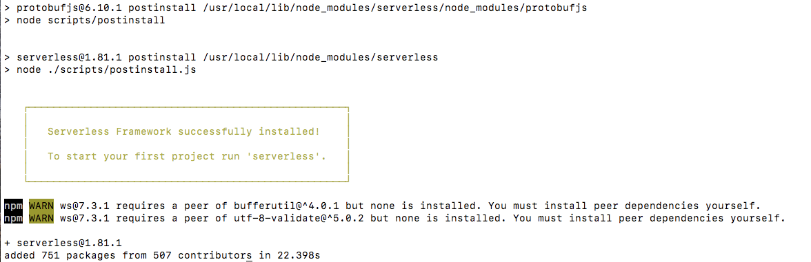

>> sudo npm install -g serverless

>> serverless help

>> sls

>> sls -v

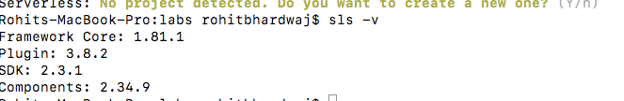

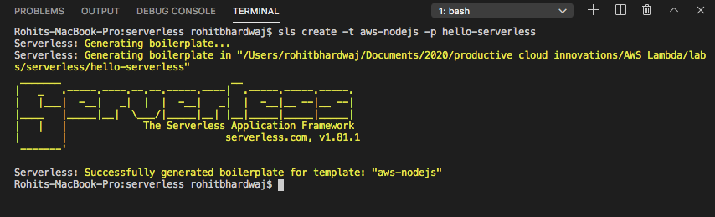

$ sls create -t aws-nodejs -p hello-serverless